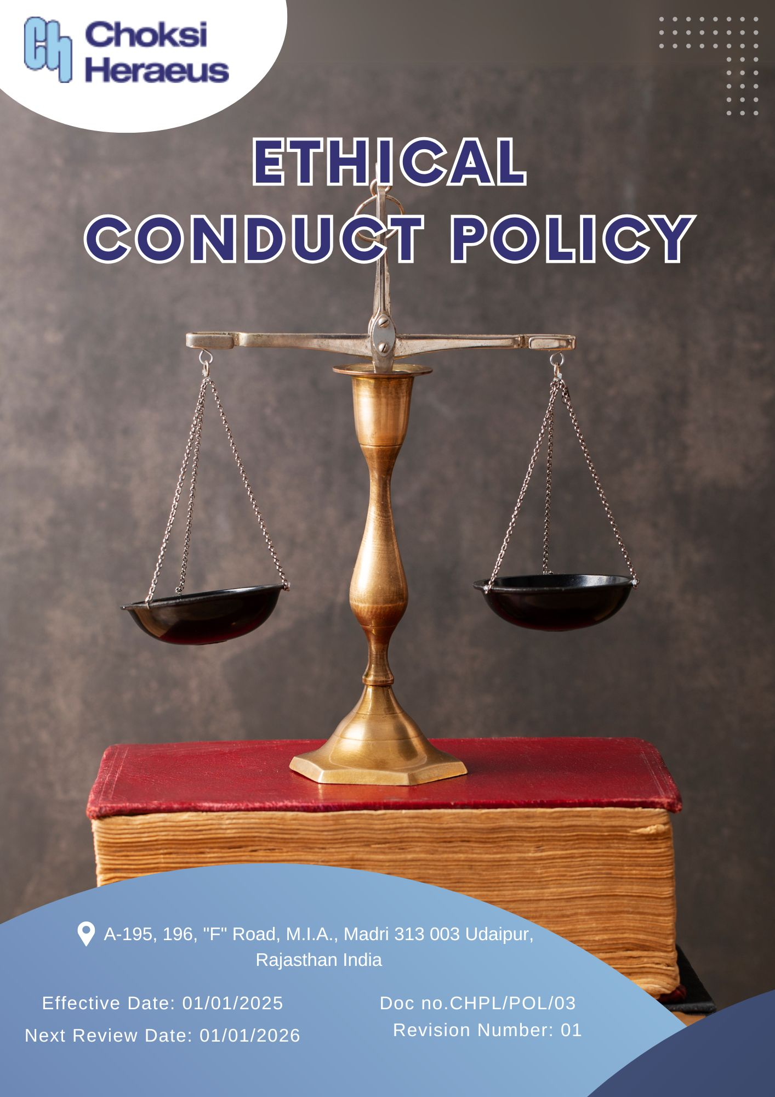

Table of Contents
Introduction 3
Scope 3
Policy Declaration 3
Key Focus Areas 4
Objectives and Targets 4
Targets in alignment with SDGs 6
Examples and Guidance 7
Continuous Improvement 8
Addressing Policy Violations 9
Responsibilities 10
Review Mechanism 10
Employee Acknowledgment Form 11

Introduction
Choksi Heraeus Pvt. Ltd. is committed to conducting its business with the highest standards of integrity, transparency, and accountability. Ethical conduct forms the cornerstone of our operations, guiding every decision and interaction across all levels of the organization. This policy reflects our dedication to upholding ethical principles in all aspects of our business, whether in our dealings with employees, customers, suppliers, or the wider community.
Through this Ethical Conduct Policy, we aim to foster a culture of honesty, fairness, and mutual respect, while ensuring compliance with all applicable laws and internal codes of practice. It outlines the expectations placed on all stakeholders to act responsibly, avoid conflicts of interest, safeguard company assets, and uphold the reputation of Choksi Heraeus as a trusted and responsible corporate entity.

Scope
This policy applies to all employees, directors, contractors, and third-party partners of Choksi Heraeus across all locations. It governs ethical behavior in all business dealings, ensuring consistent standards across operations, subsidiaries, and entities acting on behalf of the company.
Sr. No. | Site | Address
1 | CHOKSI HERAEUS PVT. LTD | A-195, 196, "F" Road, M.I.A., Madri 313 003 Udaipur, Rajasthan India

Policy Declaration
We at Choksi Heraeus are committed to maintain the highest standards of ethical behavior, integrity, and compliance in all business activities. All employees, management, and partners are expected to avoid conflicts of interest, refrain from bribery, corruption, and fraud, and ensure responsible use of company resources. Confidentiality must be respected, and all actions should align with applicable laws and internal policies. A safe, retaliation-free channel is maintained for reporting unethical conduct, reinforcing our culture of accountability and transparency.

Key Focus Areas
- Integrity in Business Practices: Promote transparency, accountability, and adherence to ethical standards in all dealings ie: internal and external.
- Prevention of Corruption: Maintain zero tolerance toward bribery, kickbacks, and undue influence, ensuring compliance with all anti-corruption laws.
- Conflict of Interest Management: Require timely disclosure of personal or professional interests that may interfere with impartial decision-making.
- Fraud Prevention and Detection: Strengthen controls to detect, report, and prevent fraudulent acts through regular audits, awareness, and whistleblower mechanisms.
- Anti-Money Laundering Measures: Apply rigorous due diligence on financial transactions and third parties to identify and prevent money laundering activities.
- Upholding Fair Competition: Ensure compliance with antitrust laws, prohibit unfair trade practices, and foster a competitive, ethical market environment.
- Responsible Information Handling: Safeguard sensitive company, client, and employee data, ensuring ethical use, storage, and communication of information.
- Transparency in Recordkeeping: Maintain accurate, honest, and timely documentation across financial and operational processes to support legal and ethical accountability.
- Respect for Stakeholder Trust: Build long-term trust through ethical engagements with customers, suppliers, partners, and the community, ensuring responsible representation of the company’s values.

Objectives and Targets
The FY 2022-23 serves as the baseline for all ethical governance targets at Choksi Heraeus, including those related to business integrity, anti-corruption, conflict of interest, fraud prevention, and anti-money laundering. Progress will be measured against this baseline to ensure continuous improvement through years with the targets set for FY 2028-29.
- Integrity in Business Practices
- Maintain a culture of ethical decision-making at all organizational levels and ensure consistency in applying ethical standards in all internal and external operations.
- Conduct annual ethics training for 100% of employees in key functions.
- Conduct an internal ethics audit across 100% departments by FY 2028-29.
- Integrate ethical conduct metrics in 100% of employee performance reviews by FY 2028-29.

- Prevention of Corruption
- Maintain a zero-tolerance policy for bribery and corruption and ensure strict compliance with anti-corruption laws and company policies.
- Maintain inclusion and compliance of anti-bribery clauses into 100% of supplier and partner contracts by FY 2028-29.
- Train 100% of procurement and finance teams on anti-corruption policies annually.
- Maintain zero instances of corruption reported in annual audits.

- Conflict of Interest Management
- Promote a culture of transparency, encouraging employees to avoid situations where personal interests could conflict with business interests.
- Ensure implementation of clear procedures for handling potential conflicts of interest fairly and impartially.
- Ensure that 100% of new hires complete conflict-of-interest training within their first week.
- Achieve 100% completion rate of annual conflict of interest disclosures by all managers by FY 2028-29.

- Fraud Prevention and Detection
- Provide training on identifying, preventing, and reporting fraud to all employees and encourage a culture of accountability, where fraudulent activities are promptly reported and addressed.
- Strengthen awareness and controls through regular reviews.
- Conduct fraud risk assessments across all functions annually.
- Maintain zero fraud - related incidents annually.
- To Maintain the implementation of a fraud detection mechanism to monitor and flag suspicious activities, aiming for a 100% reduction in undetected fraudulent transactions by FY 2028-29.

- Anti-Money Laundering Measures
- Regularly monitor and audit financial transactions to detect any suspicious activity
- Maintain zero number of false positive alerts in AML monitoring systems by FY 2028-29.
- Screen 100% of high-risk third parties annually using AML compliance checks.
- Train 100% of finance and legal staff on AML procedures annually.

- Upholding Fair Competition
- Ensure compliance with fair competition and antitrust laws and hence promote transparency and fairness in all market dealings.
- Conduct annual fair competition training for 100% of sales and marketing teams.
- Maintain zero incidents of regulatory fines or violations related to anti-competitive practices annually.

- Responsible Information Handling
- Protect sensitive business, employee, and client data and hence promote responsible information security, storage, and access control.
- Maintain 100% compliance with internal information security protocols in annual IT audits.
- Train 100% of staff with access to sensitive information on data security annually.
- Conduct phishing and cybersecurity drills annually.
- Maintain the implementation of encryption and other protective measures for 100% of sensitive information by FY 2028-29.
- Implement mandatory password and access reviews every six months for all critical systems.

- Transparency in Recordkeeping
- Enable full legal and operational traceability through systematic documentation.
- Maintain the Digitilization for 100% of financial records.
- Train 100% of relevant employees on document retention and compliance annually.

Targets in alignment with SDGs
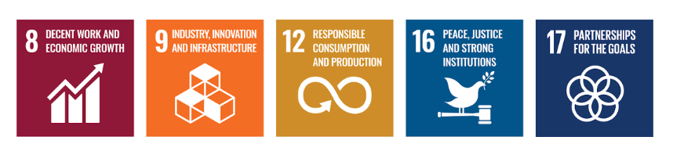

Examples and Guidance
To support consistent understanding and implementation of this Ethical Conduct Policy, the following topic-wise examples and guidance offer practical interpretations of expectations and actions:

- Integrity in Business Practices
- Example: An employee discovers that a colleague is inflating product performance data to secure a contract.
- Guidance: The employee should immediately report the misconduct to the compliance team. All business practices must reflect honesty and integrity. Employees should avoid misrepresentation and adhere to the company’s ethical code.

- Prevention of Corruption
- Example: A supplier offers a procurement executive luxury event tickets in return for favorable contract terms.
- Guidance: The executive must decline the offer and report it to the compliance officer. Accepting such gifts violates anti-corruption policies. Employees must maintain objectivity and transparency in all supplier dealings.
- Conflict of Interest Management
- Example: A project manager is asked to evaluate a vendor owned by their spouse.
- Guidance: The manager must disclose the relationship and recuse themselves from the selection process. All potential conflicts must be reported, and decisions must be made without personal bias or undue influence.

- Fraud Prevention and Detection
- Example: A finance team member notices duplicate invoices submitted by a vendor for payment.
- Guidance: The incident should be flagged and investigated immediately. Employees should report any financial irregularities through proper channels and ensure transactions are thoroughly reviewed.

- Anti-Money Laundering Measures
- Example: A customer asks to divide a large transaction into smaller amounts to avoid reporting thresholds.
- Guidance: This is a red flag for potential money laundering. The transaction must be reported and flagged for review as per AML protocols. Employees must be trained to recognize and respond to suspicious financial behavior.

- Upholding Fair Competition
- Example: A sales executive receives confidential pricing information about a competitor’s bid for the same project.
- Guidance: The executive must not use or distribute the information. Employees must avoid unfair competitive practices and must comply with antitrust and fair trade regulations.

- Responsible Information Handling
- Example: An employee accidentally leaves printed confidential client information in a public area.
- Guidance: The breach must be reported to IT and compliance immediately. Sensitive data must be securely stored and disposed of. Employees should follow data protection protocols at all times.

- Transparency in Recordkeeping
- Example: A manager delays recording a high-value expense to make quarterly results appear better.
- Guidance: All transactions must be recorded accurately and timely. Manipulating records undermines transparency and can lead to legal consequences. Employees must follow recordkeeping standards and reporting timelines.

Continuous Improvement
At Choksi Heraeus Pvt. Ltd., Ethical Conduct practices are continuously enhanced to stay aligned with evolving regulations, industry standards, and emerging risks. A strong culture of integrity is embedded across all levels of the organization, ensuring transparency, accountability, and regulatory compliance.

- Ongoing Training & Awareness: Employees undergo annual training on key ethical topics, including anti-corruption, conflict of interest, fraud prevention, anti-money laundering (AML), and information security.
- Risk Assessments & Independent Audits: Regular internal reviews and third-party audits help identify potential ethical risks, evaluate policy effectiveness, and drive corrective actions.
- Collaborative Compliance Engagement: Active participation in industry forums and regulatory dialogues supports alignment with best practices and ethical norms.
- Advanced Monitoring & Reporting Systems: Secure digital tools and automated monitoring mechanisms strengthen fraud detection, compliance management, and incident reporting.
- Feedback & Transparency Culture: Open channels for feedback empower employees and stakeholders to share concerns or suggestions, driving continual ethical improvements.

Addressing Policy Violations
Choksi Heraeus Pvt. Ltd. maintains a zero-tolerance stance on all forms of ethical misconduct, including corruption, conflicts of interest, fraud, money laundering, and data breaches. Any confirmed violations are met with strict and proportionate disciplinary measures to uphold ethical standards.

- Reporting Mechanism
- Employees, suppliers, and external stakeholders are encouraged to report suspected violations through a secure and confidential whistleblower system that guarantees anonymity and protection against retaliation.
- All reported concerns are treated with the utmost confidentiality and addressed through prompt and thorough investigation.

- Investigation & Disciplinary Actions
- Investigations are led by the Compliance Officer, with support from internal teams or external experts as needed.
- Confirmed violations may result in disciplinary actions such as warnings, suspension, termination, or legal action.
- Suppliers found in violation of ethical standards may face contract suspension, financial penalties, or disqualification from future engagements.

- Corrective & Preventive Actions
- Following any ethical breach, corrective actions such as policy updates, enhanced controls, or targeted training are implemented to prevent recurrence.
- Insights gained from incidents are integrated into risk assessments and policy reviews, contributing to stronger ethical governance and resilience.

Responsibilities
- Compliance Officer: Ensures implementation of ethical policies and compliance with anti-corruption, conflict of interest, fraud, and information security standards.
- HR Manager: Oversees employee training on ethical conduct, including anti-corruption and conflict-of-interest policies.
- IT Manager: Safeguards company and customer data through secure information systems.
- Internal Audit Team: Conducts audits to assess policy compliance and identify risks.
- Senior Management: Reviews ethical performance, allocates resources, and promotes a culture of integrity.

Review Mechanism
The Ethical Conduct Policy is reviewed annually to ensure its continued relevance, effectiveness, and alignment with legal and regulatory requirements. The Compliance Officer, in coordination with the Internal Audit Team and HR Department, is responsible for initiating the review process.
Updates may be made based on audit findings, changes in applicable laws, employee feedback, or evolving business practices. Any revisions are communicated to all employees, and necessary training is provided to ensure awareness and compliance.
Effective Date: 01.01.2025
Next Review Date: 01.01.2026
Approved By:

Employee Acknowledgment Form
I acknowledge that I have received, read, and understood the Ethical Conduct Policy of Choksi Heraeus Pvt. Ltd. I agree to uphold the principles outlined in this policy, including preventing corruption, managing conflicts of interest, combating fraud, ensuring compliance with anti-money laundering regulations, and safeguarding information security.
I understand that it is my responsibility to adhere to this policy in all professional activities and to report any ethical concerns or violations through the designated reporting channels. I acknowledge that non-compliance may result in disciplinary action in accordance with company regulations.
By signing this acknowledgment, I confirm my commitment to integrity, transparency, and ethical conduct in all aspects of my work.

Employee Name  Employee ID  Date  Signature | :_______________________________  :_______________________________ :________________________________  : _______________________________

